# Replacing the IVR with Intelligent Agent Technology

[Goal](#_Toc117746230)

[Background](#_Toc117746231)

[Related Documents](#_Toc117746232)

**Description:** This document introduces the new Intelligent Agent technology that will create a new and improved member experience when calling CVS Caremark. The Intelligent Agent will replace the existing IVR in a phased approach over the next 12 months. Members will interact with a “Digital colleague” that uses speech recognition and natural language understanding leading to more human-like and pleasant interactions.

|  |
| --- |
| Goal |

Transition our current self-service IVR to a more human-like, conversational experience with Intelligent Agent. To improve the likelihood a member will use self-service and free up agents to help members with the most complex needs.

[Top of the Document](#_top)

|  |
| --- |
| Background |

**What is the Change?**

Intelligent Agent technology will replace the current IVR system. Leveraging the power of Artificial Intelligence, Intelligent Agent will better understand the caller’s needs and streamline their call experience. The system will be able to understand multiple pieces of information from a single member dialog and enable members to correct input provided at a previous step.

**Benefits to Members:**

* Decreases member phone interaction time
* Reduces caller wait time
* Enhances Service Quality
* Predictive offers create member personalization
* Human-Like Experience

**How the Enhancement Works:**

The traditional IVR takes a multi-step question approach to collect inputs from the caller. Intelligent Agent provides a more human-like, conversational experience by understanding multiple pieces of information from a single member dialog and providing a more streamlined interaction.

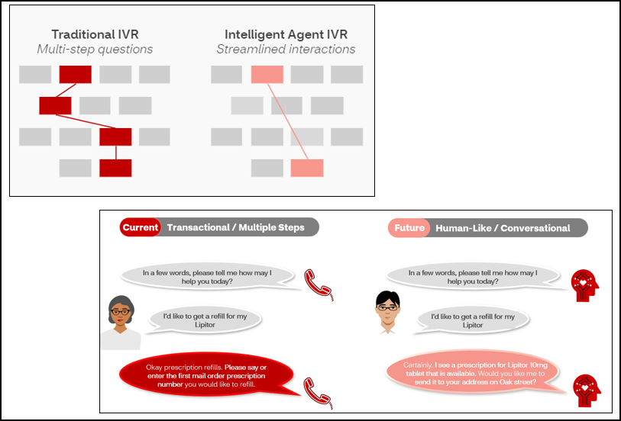

**What are the stages of installation?**

Intelligent Agent will be introduced in a phased approach. During the pilot / transition period, the existing IVR will remain functioning for clients and modules that have yet to be upgraded to Intelligent Agent.

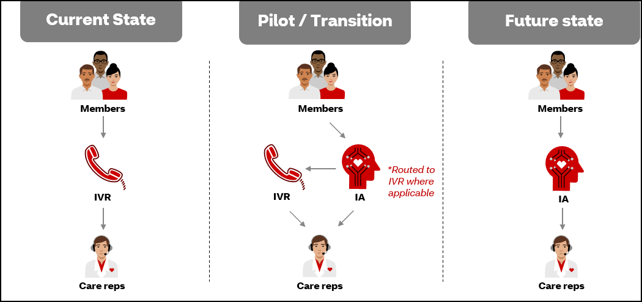

**When is it Occurring?**

The initial rollout will include **ONLY** the Drug Price module and is planned for release to CVS Health employees in Q4 2022. Rollouts to additional modules and client groupings will follow, with all remaining clients using this new technology by the end of 2023.

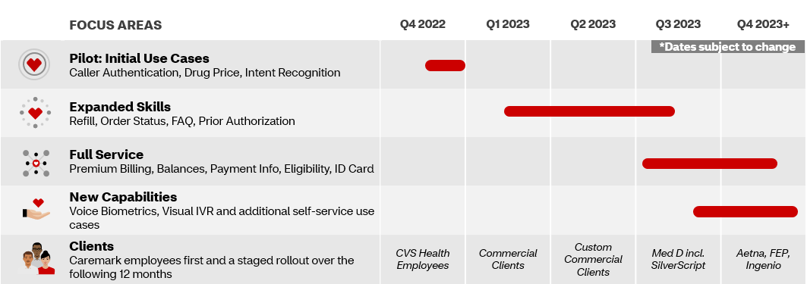

**How will I know if the caller has been rolled into this new feature?**

Callers will encounter the Intelligent Agent before reaching Customer Care. The system will not identify whether the caller has received the Intelligent Agent update and there will be no change to the post-IVR experience. Therefore, there should be no change in procedure for handling these callers.

**How do I assist callers?**

By the time the member reaches customer Care, there should be no change to the experience, and you should serve as you always have. If the caller identifies that they experienced a change in the IVR, please inform callers that the automated phone system is being improved to provide a better experience and improve the ability for callers to self-serve. Encourage members that the new technology uses speech recognition and natural language understanding to provide a more human-like, conversational interaction.

Questions on Intelligent Agent can be directed to [**IntelligentAgentPBM@cvshealth.com**](mailto:IntelligentAgentPBM@cvshealth.com)however, if the caller reports any issues that need to be reported, please submit an IVR Research Request.

[Top of the Document](#_top)

|  |
| --- |
| Related Documents |

[Customer Care Abbreviations, Definitions and Terms Index (017428)](https://thesource.cvshealth.com/nuxeo/thesource/" \l "!/view?docid=c1f1028b-e42c-4b4f-a4cf-cc0b42c91606" \t "_blank)

[Top of the Document](#_top)

Not to Be Reproduced or Disclosed to Others without Prior Written Approval

**ELECTRONIC DATA = OFFICIAL VERSION / PAPER COPY = INFORMATIONAL ONLY**